B1 FROM BASE 16 TO 10

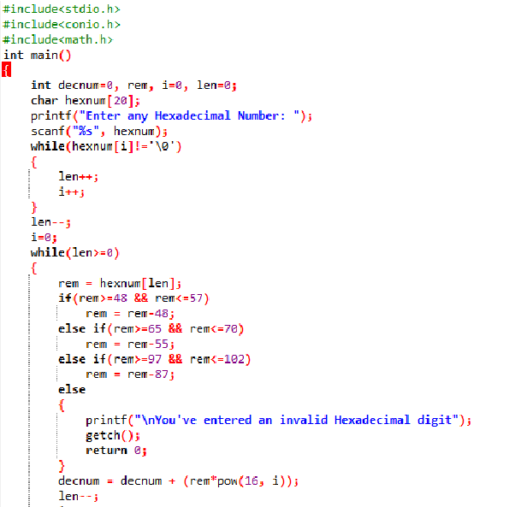

OUTPUT

